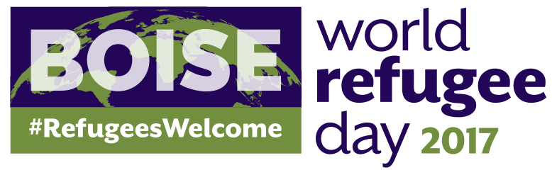

Saturday June 17, 2017 Grove Plaza & Ann Morrison Park, Boise

Support Idaho’s refugee community as they share their talents and cultures with Boise!

Boise will honor World Refugee Day, a UN initiative, with a celebration on the Grove Plaza and a Soccer Friendly at Ann Morrison Park on Saturday, June 17th. The event is put on through a partnership between the Idaho Office for Refugees, International Rescue Committee, World Relief, Agency for New Americans, the English Language Center, and Capital City Public Market. World Refugee Day uses art and performance to deliver positive educational messages that counter fear and ignorance and promote awareness of the plights of refugees worldwide. We are inviting sponsors to join us in helping make this year’s event a success.

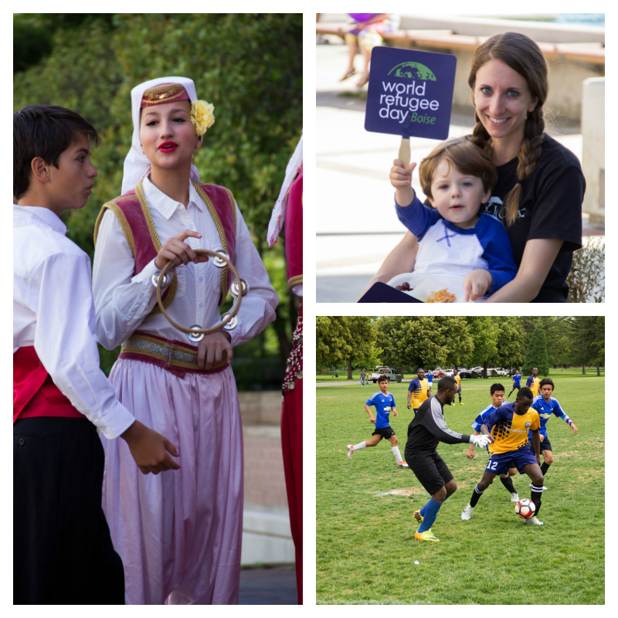
Sponsorship Opportunities

Presenting Sponsor $2,500+
Presenting Sponsors Filled for 2017!
- Allotted time on stage to speak at Celebration event
- Special on-stage recognition and certificate of appreciation
- Banner space on stage
- Organization’s logo on promotional materials
- Organization’s logo on website and social media pages
Organization’s name in press materials

Platinum Sponsor $1000
- Special on-stage recognition and certificate of appreciation
- Banner space on stage
- Organization’s logo on promotional materials
- Organization’s logo on website and social media pages
Organization’s name in press materials

Gold Sponsor $500
- Banner space on stage
- Organization’s logo on promotional materials
- Organization’s logo on website and social media pages
- Organization’s name in press materials

Silver Sponsor $250
- Organization’s logo on promotional materials
- Organization’s logo on website and social media pages
- Organization’s name in press materials

Sponsorships due May 10th, 2017
To sponsor, fill out the form below or register online (www.idahorefugees.org/worldrefugeeday)

Saturday June 17, 2017 Grove Plaza, Downtown Boise

Sponsorship Application

Thank you for supporting Boise’s World Refugee Day!

Organization Name:

Contact Name:

Contact Phone Number:

Contact E-mail Address:

Sponsorship Amount:

Comments:

We will be in touch soon to discuss your sponsorship. Please return this form via e-mail, fax, or post to:

Kara Fink
Idaho Office for Refugees
1607 W Jefferson
Boise, ID 83702
tel. 208.336.4222
fax 208.331.0267
kfink@idahorefugees.org
www.idahorefugees.org/worldrefugeeday

